Name: - Devashish Shrinivas Patil

Q1.

Ans. Html

<!DOCTYPE html>

<html lang="en">

<head>

    <meta charset="UTF-8">

    <meta name="viewport" content="width=device-width, initial-scale=1.0">

    <title>Document</title>

  <link rel="stylesheet" href="style.css">

</head>

<body>

  <div class="container">

    <div class="Extra">

        <h1>LOGO</h1>

        Lorem ipsum, dolor sit amet consectetur adipisicing elit, sed diam nonummy nibh euismod tincidunt

    </div>

    <div class="center">

        <center>

        <h1>Create An Account</h1>

      <img src="login.jpg" alt="Logo" class="logo">

      <h2>Sign up to continue</h2>

    </center>

      <form>

        <input type="text" placeholder="Name" required>

        <input type="text" placeholder="Surname" required>

        <input type="text" placeholder="userid" required>

        <input type="email" placeholder="email" required>

        <input type="email" placeholder="Recovery email" required>

        <input type="password" placeholder="password" required>

        <input type="password" placeholder="Retype Password" required>

      </form>

        <input type="checkbox">I agree to the terms and conditions   <br>

        <button type="submit">Submit</button>

        <p>Already have an account? Sign in here.</p>

    </div>

    <div class="right">

        <center>

            <h1 style="color: white;">LOGO</h1><br>

            <h1>Create An Account</h1>

          <img src="login.jpg" alt="Logo" class="logo">

          <h2 style="font-size: 15px;">Sign up to continue</h2>

        </center>

      <form>

        <input type="text" placeholder="Name" required>

        <input type="text" placeholder="Surname" required>

        <input type="text" placeholder="userid" required>

        <input type="email" placeholder="email" required>

        <input type="email" placeholder="Recovery email" required>

        <input type="password" placeholder="password" required>

        <input type="password" placeholder="Retype Password" required>

      </form>

        <input type="checkbox">I agree to the terms and conditions   <br>

        <button type="submit">Submit</button>

        <p>Already have an account? Sign in here.</p>

    </div>

  </div>

</body>

</html>

CSS

* {

    box-sizing: border-box;

    margin: 0;

    padding: 0;

  }

  .container {

    display: flex;

    background: linear-gradient(to right, purple, pink);

    height: 100%;

    position: absolute;

  }

  .Extra{

    width: 30%;

    padding-top: 20%;

    padding-left: 10%;

    background: rgba(150, 149, 149, 0.889);

    opacity: 0.9;

    margin-left: 50px;

    margin-top: 30px;

    margin-bottom: 25px;

    font-size: larger;

  }

  .Extra h1{

    color: blue;

    padding-left: 15%;

  }

  .center {

    width: 40%;

    opacity: 0.9;

    background: rgba(150, 149, 149, 0.889);

    margin-top: 30px;

    margin-right: 50px;

    margin-bottom: 25px;

    padding-top: 35px;

    padding-right: 25px;

  }

  .right {

    width: 400px;

    margin-top: 30px;

    margin-right: 50px;

    margin-bottom: 25px;

    background: rgba(150, 149, 149, 0.889);

    color: black;

    padding-top: 5px;

    padding-left: 30px;

    padding-right: 70px;

    opacity: 0.9;

  }

  .logo {

    width: 100px;

    border-radius: 50px;

  }

  h1 {

    font-size: 30px;

  }

  form {

    display: flex;

    flex-direction: column;

  }

  input {

    margin: 5px 0;

    padding: 10px;

  }

  button {

    margin: 10px 0;

    padding: 10px;

margin-left: 50%;

    width: 5cm;

  }

Output: -

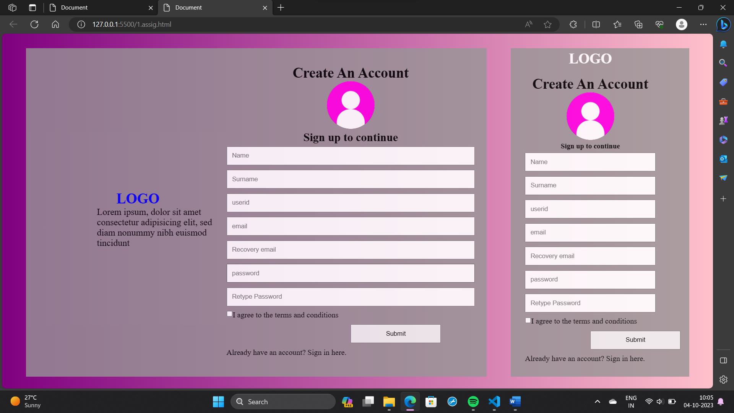

Q2.

Ans.

<!DOCTYPE html>

<html lang="en">

    <head>

        <meta charset="UTF-8">

        <meta name="viewport" content="width=device-width, initial-scale=1.0">

        <title>Create Account</title>

    </head>

    <style>

        body{

            background-color: black;

        }

        .center{

            width: 330px;

            height: 350px;

            padding-top: 30px;

            margin: auto;

            background-color: #0a1f3c;

            border-radius: 10px;

            color: white;

            font-family: Arial, sans-serif

        }

        .center h1 {

            text-align: center;

            margin-top: 20px;

        }

        .center h2 {

            text-align: center;

            margin-bottom: 20px;

            color: white;

        }

        .center input {

            display: block;

            width: 80%;

            margin: 20px auto;

            border-radius: 11%;

            padding: 10px;

            border: none;

            background-color: rgb(203, 195, 236);

            opacity: 0.5;

            color: black;

        }

        .center button {

            display: block;

            width: 50%;

            margin: 10px auto;

            border-radius: 11%;

            padding: 10px;

            border: none;

            background-color: #6db4ff;

            color: white;

            cursor: pointer;

        }

        ::placeholder{

            color: white;

        }

    </style>

    <body>

        <main>

            <div class="center">

                <h1>Welcome</h1>

                <h2>Let's create your account!</h2>

                <form>

                    <input type="text" name="first_name" placeholder="First name">

                    <input type="text" name="last_name" placeholder="Last name">

                    <input type="email" name="email" placeholder="Email">

                    <button type="submit">Submit</button>

                </form>

            </div>

        </main>

    </body>

</html>

Output: -

